Java Interview

# Java Core

## OOP

1. Inner class and nested Static Class in Java with Example

if a class can only be useful to one particular class, it make sense to keep that inside the class itself  otherwise declare it as top level class. I actually look JDK itself for examples and if you look HashMap class, you will find that Map.Entry is a good example of nested class in Java. Another popular use of nested classes are implementing [Comparator in Java](http://javarevisited.blogspot.sg/2011/06/comparator-and-comparable-in-java.html) e.g. AgeCompartor for Person class.

First and most important difference between Inner class and nested static class is that Inner class require [instance](http://javarevisited.blogspot.sg/2012/02/difference-between-instance-class-and.html) of outer class for initialization and they are always associated with instance of enclosing class. On the other hand nested static class is not associated with any instance of enclosing class.

Another difference between Inner class and nested static class is that later uses static keyword in there class declaration, which means they are static member of class and can be accessed like any other static member of class.

1. Checked vs Unchecked Exception in Java Example

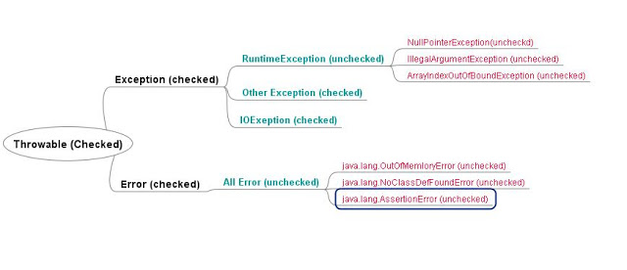

Checked Exception is required to be handled by compile time while Unchecked Exception doesn't.

Checked Exception is direct sub-Class of Exception while Unchecked Exception are of RuntimeException. CheckedException represent scenario with higher failure rate while UnCheckedException are mostly programming mistakes.

1. How to create thread safe Singleton in Java - Java Singleton Example?

Singleton using Enum in Java

By default creation of Enum instance is thread safe but any other method on Enum is programmers responsibility.

**public** **enum** EasySingleton{  
    INSTANCE;  
}

Singleton example with double checked locking

***/\*\*  
\* Singleton pattern example with Double checked Locking  
\*/***

**public** **class** DoubleCheckedLockingSingleton{  
     **private** **volatile** DoubleCheckedLockingSingleton INSTANCE;  
    
     **private** DoubleCheckedLockingSingleton(){}  
    
     **public** DoubleCheckedLockingSingleton getInstance(){  
         **if**(INSTANCE == **null**){  
            **synchronized**(DoubleCheckedLockingSingleton.**class**){  
                *//double checking Singleton instance*  
                **if**(INSTANCE == **null**){  
                    INSTANCE = **new** DoubleCheckedLockingSingleton();  
                }  
            }  
         }  
         **return** INSTANCE;  
     }  
}

Singleton pattern with static factory method

This is one of my favorite method to impelemnt Singleton pattern in Java, Since Singleton instance is [static](http://javarevisited.blogspot.sg/2011/11/static-keyword-method-variable-java.html) and [final variable](http://javarevisited.blogspot.sg/2011/12/final-variable-method-class-java.html) it initialized when class is first loaded into memeory so creation of instance is inherently thread-safe.

***/\*\*  
\* Singleton pattern example with static factory method  
\*/***  
  
**public** **class** Singleton{  
    *//initailzed during class loading*  
    **private** **static** **final** Singleton INSTANCE = **new** Singleton();  
    
    *//to prevent creating another instance of Singleton*  
    **private** Singleton(){}  
  
    **public** **static** Singleton getSingleton(){  
        **return** INSTANCE;  
    }  
}

Enum Singletons handled Serialization by themselves

Another problem with conventional Singletons are that once you implement [serializable interface](http://javarevisited.blogspot.sg/2011/04/top-10-java-serialization-interview.html) they are no longer remain Singleton because readObject() method always return a new instance just like constructor in Java. you can avoid that by using readResolve() method and discarding newly created instance by replacing with Singeton as shwon in below example :

*//readResolve to prevent another instance of Singleton*  
    **private** Object readResolve(){  
        **return** INSTANCE;  
    }

1. How HashMap works?

<https://javarevisited.blogspot.com/2011/02/how-hashmap-works-in-java.html>

1. What is the difference between creating String as new() and literal?

When we create the string with new() Operator, it’s created in heap and not added into string pool while String created using literal are created in String pool itself which exists in PermGen area of heap

**String** str **=** **new** **String**("Test")

does not put the object str in String pool, we need to call String.intern() method which is used to put them into String pool explicitly. It's only when you create String object as String literal e.g. String s = "Test" Java automatically put that into String pool.

1. How clone method works in Java?

The clone() method is used to create a copy of an Object in Java.

Since Object class' clone() method creates copy by creating new instance, and then copying field-by-field, similar to assignment operator, it's fine for primitives and Immutable object, but not suited if your class contains some mutable data structure e.g. Collection classes likeArrayList or [arrays](http://javarevisited.blogspot.sg/2011/06/converting-array-to-arraylist-in-java.html). In that case, both original object and copy of the object will point to the same object in the heap. You can prevent this by using the technique known as deep cloning, on which each mutable field is cloned separately.

* Any class calls clone() method on an instance, which implements Cloneable and overrides protected clone() method from Object class, to create a copy.
* Call to clone() method on Rectangle is delegated to super.clone(), which can be a custom [superclass](http://java67.blogspot.sg/2013/06/difference-between-this-and-super-keyword-java.html) or by default java.lang.Object.

 @Override

**protected** Rectangle **clone**() **throws** CloneNotSupportedException {

**return** (Rectangle) **super**.clone();

    }

* Eventually, call reaches to java.lang.Object's clone() method, which verify if the corresponding instance implements Cloneable interface, if not then it throws CloneNotSupportedException, otherwise it creates a field-by-field copy of the instance of that class and returned to the caller.

<https://javarevisited.blogspot.com/2013/09/how-clone-method-works-in-java.html#more>

<https://javarevisited.blogspot.com/2015/01/java-clone-tutorial-part-2-overriding-with-mutable-field-example.html>

## Multithreading, concurrency and thread basics

1. What is Thread in Java?

* Threads consumes CPU in best possible manner, hence enables multi processing. Multi threading reduces idle time of CPU which improves performance of application.
* Thread are light weight process.
* A thread class belongs to java.lang package.
* We can create multiple threads in java, even if we don’t create any Thread, one Thread at least do exist i.e. main thread.
* Multiple threads run parallelly in java.
* Threads have their own stack.
* Advantage of Thread : Suppose one thread needs 10 minutes to get certain task, 10 threads used at a time could complete that task in 1 minute, because threads can run parallely.

1. Does Thread implements their own Stack, if yes how? (Important)

Yes, [Threads have their own stack](http://www.javamadesoeasy.com/2015/03/threads-implement-their-own-stack.html). This is very interesting question, where interviewer tends to check your basic knowledge about how [threads internally maintains their own stacks](http://www.javamadesoeasy.com/2015/03/threads-implement-their-own-stack.html). I’ll be explaining you the concept by diagram.

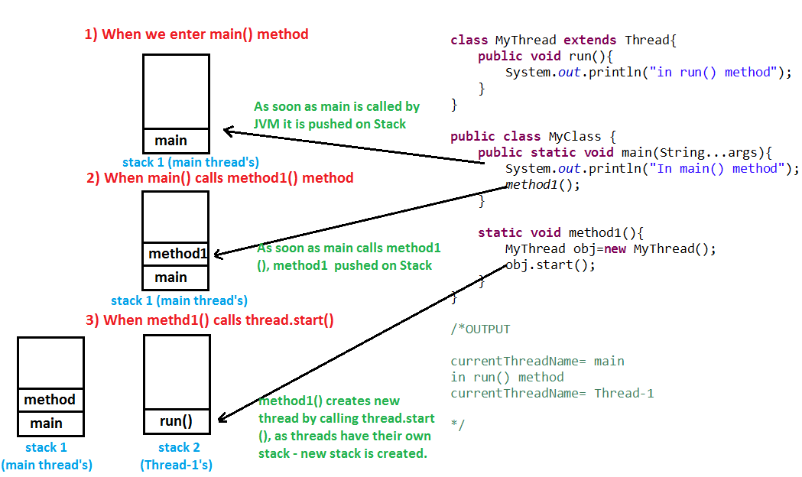

1. What is the difference between a Thread and an Executor?

Creating a running thread in Java is an expensive operation, and an operating system may limit the number of threads provided to a running application at any one time. By using a thread pool, you can create threads when needed, and, rather than creating new threads, you can reuse a thread after it has completed running previous code.

1. How can you ensure all threads that started from main must end in order in which they started and also main should end in last? (Important)

We can use [join() method](http://www.javamadesoeasy.com/2015/03/join-method-ensure-all-threads-that.html) to ensure all threads that started from main must end in order in which they started and also main should end in last.In other words waits for this thread to die. Calling join() method internally calls join(0);

<https://www.journaldev.com/1024/java-thread-join-example>

1. What is significance of using [Volatile](http://www.javamadesoeasy.com/2015/03/volatile-keyword-in-java-difference.html) keyword? (Important)

If a field is declared [volatile](http://www.javamadesoeasy.com/2015/03/volatile-keyword-in-java-difference.html), in that case the Java memory model ensures that all threads see a consistent value for the variable.

<http://www.javamadesoeasy.com/2015/03/volatile-keyword-in-java-difference.html>

1. Why wait(), notify()  and notifyAll() are in Object class and not in Thread class? (Important)

Every Object has a monitor, acquiring that monitors allow thread to hold lock on object.

wait(), notify() and notifyAll() are called on objects only > When wait() method is called on object by thread it waits for another thread on that object to release object monitor by calling [notify() or notifyAll()](http://www.javamadesoeasy.com/2015/03/difference-between-notify-and-notifyall.html) method on that object.

1. What is ThreadLocal?

Java ThreadLocal is used to create thread-local variables. We know that all threads of an Object share it’s variables, so if the variable is not thread safe, we can use synchronization but if we want to avoid synchronization, we can use ThreadLocal variables.  
Every thread has it’s own ThreadLocal variable and they can use it’s get() and set() methods to get the default value or change it’s value local to Thread. ThreadLocal instances are typically private static fields in classes that wish to associate state with a thread. Check this post for small example program showing [ThreadLocal Example](https://www.journaldev.com/1076/java-threadlocal-example).

<https://www.journaldev.com/1076/java-threadlocal-example>

1. Question 20. What is [deadlock](http://www.javamadesoeasy.com/2015/03/deadlock-in-multithreading-program-to.html) in multithreading? Write a program to form [DeadLock](http://www.javamadesoeasy.com/2015/03/deadlock-in-multithreading-program-to.html)in multi threading and also how to solve DeadLock situation. What measures you should take to avoid deadlock? (Important)

https://javarevisited.blogspot.com/2010/10/what-is-deadlock-in-java-how-to-fix-it.html

Two or more threads are waiting for each other to release lock and get stuck for infinite time, situation is called deadlock.



if you provide an ordered access then problem will be resolved , here is my fixed version, which avoids deadlock by avoiding circular wait with no preemption.



1. What are differences between wait and sleep method in Java?

The only major difference is to wait for release the lock or monitor while sleep doesn't release any lock or monitor while waiting. The wait is used for inter-thread communication while sleep is used to introduce pause on execution.

<http://javarevisited.blogspot.sg/2011/12/difference-between-wait-sleep-yield.html>

1. Difference between ExecutorService.submit() and Executor.execute() methods in Java?

<https://javarevisited.blogspot.it/2016/04/difference-between-ExecutorServie-submit-vs-Executor-execute-method-in-Java.html>

1. The real difference between Process and Thread.

The main difference between them  is that a Process is a program which is executing some code and a thread is an [independent path of execution](http://javarevisited.blogspot.com/2014/07/top-50-java-multithreading-interview-questions-answers.html) in the process. A process can have more than one thread for doing independent task e.g. a thread for reading data from disk, a thread for processing that data and another thread for sending that data over the network.

Technically, most significant difference between thread is address space and context switching. All thread from a process share same address space but a process has their own address space. Similarly, context switching between process is more expensive than context switching between threads.

1. Why wait notify and notifyAll called from synchronized block or method in Java

IllegalMonitorStateException in Java which will occur if we don't call wait (), notify () or notifyAll () method from synchronized context.

In order to call the wait (), notify () or notifyAll () methods in Java, we must have obtained the lock for the object on which we're calling the method.

1. How to Stop Thread in Java Code Example

By default, a Thread stops when execution of run() method finish either normally or due to any Exception. In this article, we will How to Stop Thread in Java by using a boolean State variable or flag. Using a flag to stop Thread is a very popular way  of stopping the thread and it's also safe because it doesn't do anything special rather than helping run() method to finish itself.



*Should we make bExit Volatile*

How to Stop Thread in Java Tutorial ExampleSince every Thread has its own local memory in Java

its good practice to make bExit volatile because we may alter the value of bExit

from any thread and make it volatile guarantees that Runner will also see any update done before making bExit.

1. What is the difference between synchronized and concurrent collection in Java?

In Summary concurrent collections use advanced technique to achieve thread-safety without compromising Scalability. For example, [ConcurrentHashMap](http://javarevisited.blogspot.com/2013/02/concurrenthashmap-in-java-example-tutorial-working.html" \t "_blank)only locks certain portion of Map while Hashtable locks full map while doing iteration or performing any write operation.

1. What is the difference between Stack and Heap in Java

Why does someone this question as part of multi-threading and concurrency? because Stack is a memory area which is closely associated with threads. To answer this question, both stack and heap are specific memories in Java application. Each thread has their own stack, which is used to store local variables, method parameters and call stack. Variable stored in one Thread's stack is not visible to other. On another hand, the heap is a common memory area which is shared by all threads. Objects whether local or at any level is created inside heap. To improve performance thread tends to cache values from heap into their stack, which can create problems if that variable is modified by more than one thread, this is where volatile variables come into the picture. volatile suggest threads read the value of variable always from main memory. See this [article](http://javarevisited.blogspot.com/2013/01/difference-between-stack-and-heap-java.html) for learning more about stack and heap in Java to answer this question in greater detai

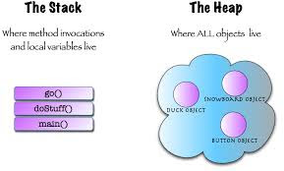

1. How to check if a thread holds lock on a particular object in Java

* I thought about **IllegalMonitorStateException**which [wait() and notify() methods](http://javarevisited.blogspot.com/2011/05/wait-notify-and-notifyall-in-java.html)throw when they get called from non-synchronized context so I said I would call newspaper.wait() and if this call [throws an exception](http://javarevisited.blogspot.com/2012/02/difference-between-throw-and-throws-in.html) it means thread in Java is not holding the lock, otherwise thread holds the lock.
* Later I discovered that thread is a static method called holdsLock(Object obj) which returns true or false based on whether threads holds a lock on the object passed (The java.lang.Thread.holdsLock() method returns true if and only if the current thread holds the monitor lock on the specified object.).

1. JavaRef:

<https://javarevisited.blogspot.it/2011/07/java-multi-threading-interview.html>

<https://javarevisited.blogspot.com/2014/07/top-50-java-multithreading-interview-questions-answers.html>

## Java collections framework

1. Difference between fail-fast Iterator vs fail-safe Iterator in Java

|  |  |
| --- | --- |
| **Fail-fast iterator** | **fail-safe iterator** |
| Structural changes means adding, removing or updating any element from collection while one thread is Iterating over that collection. fail-fast behavior is implemented by keeping a modification count and if iteration thread realizes the change in modification count it throws ConcurrentModificationException. | Contrary to fail-fast Iterator, fail-safe iterator doesn't throw any Exception if Collection is modified structurally  while one thread is Iterating over it because they work on clone of Collection instead of original collection and that’s why they are called as fail-safe iterator. Iterator of CopyOnWriteArrayList is an example of fail-safe Iterator also iterator written by ConcurrentHashMap keySet is also fail-safe iterator and never throw ConcurrentModificationException in Java. |

1. Difference between HashMap and HashSet in Java

|  |  |
| --- | --- |
| **HashMap** | **Hash Set** |
| HashMap  is an implementation of Map interface | HashSet is an implementation of Set Interface |
| HashMap Stores data in form of  key-value pair | HashSet Store only objects |
| Put method is used to add element in map | Add method is used to add element is Set |
| In hash map hashcode value is calculated using key object | Here member object is used for calculating hashcode value which can be same for two objects so equal () method is used to check for equality if it returns false that means two objects are different. |
| HashMap is faster than HashSet because unique key is used to access object | HashSet is slower than Hashmap |

1. Difference between HashMap, LinkedHashMap and TreeMap in Java

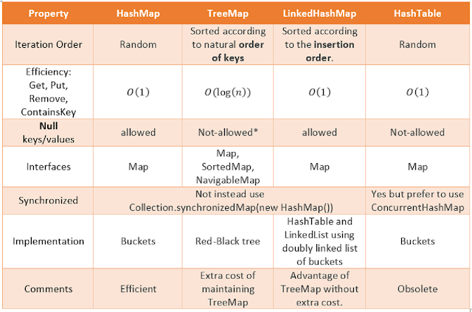

1. What is difference between Enumeration and Iterator in Java?

|  |  |
| --- | --- |
| **Enumeration** | **Iterator** |
| hasMoreElement() | hasNext() |
| nextElement() | next() |
| NA | remove() |

1. ConcurrentHashMap

<https://javarevisited.blogspot.com/2017/08/top-10-java-concurrenthashmap-interview.html>

1. How HashMap works in Java?

<https://javarevisited.blogspot.com/2011/02/how-hashmap-works-in-java.html>

1. What is difference between Synchronized and Concurrent Collections in Java?

<https://javarevisited.blogspot.com/2016/05/what-is-difference-between-synchronized.html>

1. When do you use ConcurrentHashMap in Java?

This is another advanced level collection interview questions in Java which normally asked to check whether the interviewer is familiar with optimization done on ConcurrentHashMap or not. ConcurrentHashMap is better suited for situation where you have multiple readers and one

Writer or fewer writers since Map gets locked only during the write operation. If you have an equal number of reader and writer than [ConcurrentHashMap](http://javarevisited.blogspot.com/2011/04/difference-between-concurrenthashmap.html) will perform in the line of Hashtable or synchronized HashMap.

## Hibernate

1. Entity object life cycle

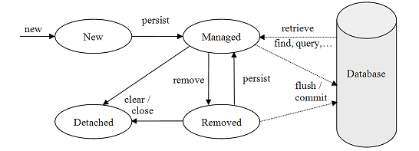

When an entity object is initially created its state is **New**.  In this state the object is not yet associated with an [EntityManager](https://www.objectdb.com/api/java/jpa/EntityManager) and has no representation in the database.

An entity object becomes Managed when it is persisted to the database via an EntityManager’s [persist](https://www.objectdb.com/api/java/jpa/EntityManager/persist_Object)method, which must be invoked within an active transaction. On transaction commit, the owning EntityManager stores the new entity object to the database. Entity objects retrieved from the database by an EntityManager are also in the Managed state.

A managed entity object can also be retrieved from the database and marked for deletion, by using the EntityManager’s [remove](https://www.objectdb.com/api/java/jpa/EntityManager/remove_Object)method within an active transaction. The entity object changes its state from Managed to Removed, and is physically deleted from the database during commit.

The last state, Detached, represents entity objects that have been disconnected from the EntityManager. For instance, all the managed objects of an EntityManager become detached when the EntityManager is closed. Working with detached objects, including merging them back to an EntityManager.

The persistence context is the collection of all the managed objects of an EntityManager. If an entity object that has to be retrieved already exists in the persistence context, the existing managed entity object is returned without actually accessing the database (except retrieval by [refresh](https://www.objectdb.com/api/java/jpa/EntityManager/refresh_Object_LockModeType), which always requires accessing the database).

The main role of the persistence context is to make sure that a database entity object is represented by no more than one in-memory entity object within the same EntityManager. Every EntityManager manages its own persistence context.

1. Difference between get and load in Hibernate

* Get method of Hibernate Session class returns null if object is not found in cache as well as on database while load() method [throws](http://javarevisited.blogspot.sg/2012/02/difference-between-throw-and-throws-in.html) ObjectNotFoundException if object is not found on cache as well as on database but never return null.
* Get method never returns a proxy, it either returns null or fully initialized Object, while load()method may return proxy, which is the object with ID but without initializing other properties, which is lazily initialized. If you are just using returned object for creating relationship and only need Id then load() is the way to go.
* load method exists prior to get method which is added on user request.

|  |
| --- |
| *//Example of calling get method of Hiberante Session class* **Session** session = SessionFactory.getCurrentSession(); **Employee** Employee = (Employee) session.get(Employee.**class**, EmployeeID);  *//Example of calling load method of Hiberante Session* **Session** session = SessionFactory.getCurrentSession(); **Employee** Employee = (Employee) session.load(Employee.**class**, EmployeeID); |

1. Difference between save vs persist and saveOrUpdate in Hibernate

Hibernate **Session** class provides couple of ways to save object into database by methods like **save**, **saveOrUpdate** and **persist**.

Main difference between save and saveOrUpdate method is that save() generates a new identifier and INSERT record into [database](http://javarevisited.blogspot.sg/2011/10/selct-command-sql-query-example.html) while saveOrUpdatecan either INSERT or UPDATE based upon existence of record. Clearly saveOrUpdate is more flexible in terms of use but it involves an extra processing to find out whether record already exists in table or not.

Hibernate persist is similar to save (with transaction) and it adds the entity object to the persistent context, so any further changes are tracked. If the object properties are changed before the transaction is committed or session is flushed, it will also be saved into database.

Second difference is that we can use persist() method only within the boundary of a transaction, so it’s safe and takes care of any cascaded objects.

Finally, persist doesn’t return anything so we need to use the persisted object to get the generated identifier value. Let’s look at hibernate persist with a simple program.

1. What is SessionFactory in Hibernate? is SessionFactory thread-safe?

SessionFactory, as the name suggest, is a factory to hibernate Session objects. SessionFactory is often built during start-up and used by application code to get session object. It acts as a single data store and it's also [thread-safe](http://javarevisited.blogspot.com/2012/12/how-to-create-thread-safe-singleton-in-java-example.html) so that multiple threads can use the same SessionFactory. Usually, a Java JEE application has just one SessionFactory, and individual threads, which are servicing client’s request obtain hibernate Session instances from this factory, that’s why any implementation of SessionFactory interface must be thread-safe.

1. What is Session in Hibernate? Can we share single Session among multiple threads in Hibernate?

Session represent a small unit of work in Hibernate, they maintain a connection with the database and they are not thread-safe, it means you can not share Hibernate Session between multiple threads. Though Session obtains database connection lazily it's good to close session as soon as you are done with it.

1. Why it's important to provide no argument constructor in Hibernate Entities?

Every Hibernate Entity class must contain a [no argument constructor](http://javarevisited.blogspot.com/2012/12/what-is-constructor-in-java-example-chainning-overloading.html), because Hibernate framework creates an instance of them using Reflection API, by calling Class.newInstance() method. This method will throw InstantiationException if it doesn't found any argument constructor inside Entity class.

1. Can we make a Hibernate Entity Class final?

Yes, you can make a Hibernate Entity class final, but that's not a good practice. Since Hibernate uses a proxy pattern for performance improvement in the case of the lazy association, by making an entity final, Hibernate will no longer be able to use a proxy, because [Java doesn't allow extension of the final class](http://javarevisited.blogspot.com/2011/12/final-variable-method-class-java.html), thus limiting your performance improvement options.

1. Difference between First and Second Level Cache in Hibernate

**Scope:**

First level cache is associated with Session Object, while the Second level cache is associated with the SessionFactory object. This means first level cache's scope is limited to session level while second level cache's scope is at the application level. Since Session object is created on demand from the SessionFactory and it's destroyed once the session is closed, the same query if run from two different sessions will hit the database twice if the second level cache is not configured. On the other hand, second level cache remains available throughout the application's life-cycle.

**Configuration:**

First level cache is by default enabled in Hibernate, while the second level cache is optional. If you need it then you need to explicitly enable the second level cache on Hibernate configuration file i.e. the hibernate.cfg.xml file

You can use the hibernate.cache.provider\_class and hibernate.cache.use\_second\_level\_cache properties to enable the second level cache in Hibernate. The first one is the name of the class which implements Second level cache and could be different, depending upon which cache you use e.g. EhCache or OSCache.

<https://javarevisited.blogspot.com/2017/03/difference-between-first-and-second-level-cache-in-Hibernate.html>